V-SET: Visual Story Editing Tool

**Subtitle: The Interactive Narrative Midterm Project Write Up.**

Student ID: 200110436

Unity ID: ychen74

Name: Yi-Chun Chen

# Outline

Introduction: Related Issues and Proposed Tool

System Description

Demo Video

Analysis and Evaluations

Future Work

Reference

License Information and Permission Information of Sample Artworks

# Introduction: Related Issues and Proposed Tool

# In current story engines, there are some authoring issues beyond tools [1]. One of the issues is the lack of useful graphical user interface, for authoring tools, which may allow authors to edit story content without working on programming language/ scripts. It causes the blur between story world and the engines. And the lack of useful graphical user interface also make authors hard to observe the generated story from different perspectives. Another related issue is that current story engines usually generate the story world as 3D simulations. Even though 3D environments are more realistic, they cost more time and computational resources to display the generated story content. As a result, authors cannot quickly see the results of generated content.

The Visual Story Editing Tool (V-SET) is an attempt to try to tackle part of these issues; it is a prototype system for graphical user interface authoring tool and will quickly display the story content through 2D graphic instead of 3D models. V-SET divides story as events which scatter on characters’ storylines, and then allows authors to arrange the events’ time orders as well as to edit the elements inside story events through graphical interface hence to change the story content. The tool uses built in display queue and display story events chronologically by adding story events into queue.

This report is going to introduce this tool. And the following content are organized in this order: the next section will describe the detail of this system, the third section will evaluate the performance and cognitive time cost of each editing action. The final section is the conclusion and future work of this tool.

# System Description

This section will introduce the underlying idea of V-SET about how it decomposes a story into sub units, the data structures for representing a story, and the system structure of this tool.

**Story decomposition**

To find the small unit that composes a story and is suitable to be edited through graphical user interface, V-SET decomposes a story as a sequence of story events; and then defines events as a group of interactions between characters which happen in a short period of time and in a same place. Besides, considering that dialogue is one type of interactions which relatively easier to be displayed and usually be used to form story content, V-SET describe a story like the structure shown in Figure 1.

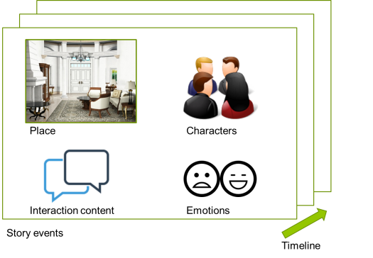

Fig. 1: A story is a sequence of story event, and an event contains a place, some characters, dialogues (interactions) between characters.

**System Structure**

To display a story and to be an authoring tool, below are functions the V-SET would like to support:

1. **Character customizing**: This function allows authors to customize characters’ visual image through alternate the image of physical characteristics.
2. **Visualized storyline**: This function allows authors to directly see and arrange story events on storyline in arbitrary order, and provide a perspective of story structure.
3. **Event editing**: This function allows authors to modify the details of a story event: including modifying the event place, adding dialogue content and assign dialogue to specific characters.
4. **Visual result generating**: After authors finish editing storyline, the tool help to compile the story and generate 2D visual results. It will display the story events according to author’s arrangement.

Therefore, to support these functions, the system structure of V-SET is divided as five sub parts. The first one is the *Interface*, which is used to interact with authors and readers. It take authors editing actions as input, and then will transform the inputs into runtime data structure and store the changes in the second part—the *Editing Buffer*. Not until the authors confirm the changes on story content, the changed content will cached in *Editing Buffer*. That is because the tool should support the flexibility of canceling current editing. Once the changes are confirmed by authors, these changes (such as the changes of character information, content of story, and so on) will update the recorded data in the third part: *Look up Maps.*

In *Look up Maps*, hash map are widely used to record the information of character, event, and visual materials, because all of these things are frequently accessed during the editing process. Hash map can provide better performance in such situations. The *Look up Maps* exchanges data with the fourth part—*Storage* while saving/ loading data and retrieving character features images. The fifth part of this system is the *Display Queue*. Once authors finish editing stories, they can ask V-SET to compile current story at any time. The compile function will trigger the actions that adding current story events into *Display Queue* chronologically. Then, the Display Queue will combine character images, dialogue content together to show the generated story to authors or readers. Figure 2 shows the data flow and the structure of the system.

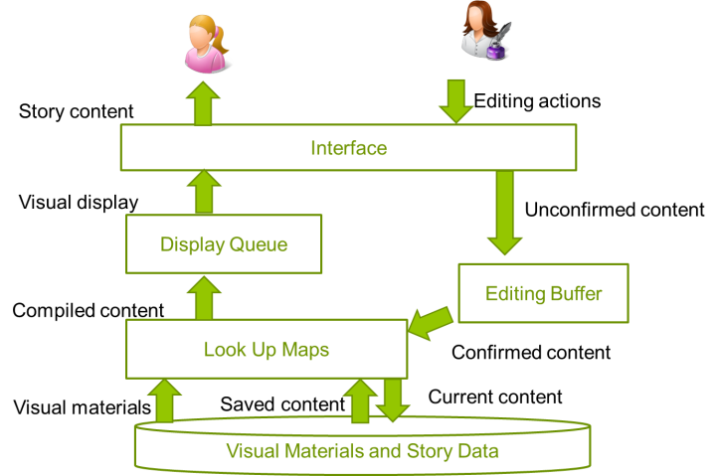

Fig. 2. The data flow of the whole process from editing story to generating result, and how data moves in-between system parts.

(The detail of data structures, the data maps are in implementation detail document).

# Demo Video

<https://youtu.be/DfeFzWGYJYs>

# Analysis and Evaluations

Since most of operations and functions of V-SET are related to graphical user interface, in the section, we use CogTool to estimate the theoretical time cost of each editing action on V-SET. CogTool is a general purpose user interface prototyping tool which employs a human performance model to automatically evaluate how efficiently a skilled user can do a task on a design.

According to the real interface frames of V-SET, the prototype for CogTool measurements are developed as Figure 3. And the Figure 4 (a)(b)(c) shows the corresponding real screenshots.

|  |  |
| --- | --- |
|  |  |
| Fig. 3. The prototype in CogTool | Fig. 4. (a)(b)(c) the real screenshots of V-SET |

We are going to evaluate following tasks:

1. Editing a character: the action involves clicking on a button with character’s name, changing any 3 features of a character, and then press save button.
2. Editing an event without adding dialogues: the action involves clicking on an event button, looking and changing the place for an event, and then press save button.
3. Editing an event and adding 2 dialogues: the action involves clicking on an event button, changing the place for an event, adding two dialogues, assigning characters to dialogues, and then press save button.
4. Editing an event and adding 3 dialogues: the action involves clicking on an event button, changing the place for an event, adding three dialogues, assigning characters to dialogues, and then press save button.

The theoretical execution time of each action is listed in Table 1.

|  |  |
| --- | --- |
| Tasks | Estimated Time (in second) |
| Task 1: Editing character with 3 features | 10.5 |
| Task 2: Editing event without dialogue | 7.8 |
| Task 3: Editing event with adding 2 dialogues | 13.9 |
| Task 4: Editing event with adding 3 dialogues | 16.2 |

Although there is not baseline to compare with the estimated time to evaluate the efficiency of this tool, from the result, we can roughly know the needed time for each editing action. The task 1 simulates the action of creating and editing the visual image of a character, which takes 10.5 seconds. That is to say with the help of the tool, if authors have already had some imagination about characters, authors can get visual image of designed character very quickly. Moreover, from task 2~4, we know that editing an event takes about 7.8 seconds. If authors would like to add more dialogues in an event, adding one dialogue takes about 3 second. It is also not a very large time cost. Therefore, authors can generate their stories and see the results by doing simple actions on V-SET.

# Future Work

In the first version of V-SET, it only support simple editing functions, and display the dialogues of a story in regular time frequency. Here are some ideas which might be helpful improve the display:

* Adding blank events between story events: since each story event may happen in different places, blank events can help the transition between scenes become smoother.
* Adding time delay between dialogues: considering that there are usually some pauses when people are telling a story, story tellers sometimes use the pause to control the rhythm of discourse. If the tool allows authors to add time delay between dialogues, it can display the result closer to what in authors’ mind.

Here are some functions which will be added in second version of V-SET.

* Functions to set transition conditions between events: this function can allow authors to create branches of story.
* Functions to set multiple choices questions in events: by this function, the system will become able to take simple interactions from readers. Combining the conditions set by authors, V-SET can generated small playable game with generated stories.

# Reference

[1] Spierling, U., and N. Szilas. “*Authoring Issues beyond Tools*.” Interactive Storytelling, 2009, 50–61.

# License and Permission Information of Sample Artworks

**Backgrounds and Dialogue Frame**

1. 誰そ彼亭 <http://may.force.mepage.jp/>

License information (quoted from site): 有料無料、ジャンル、年齢制限の有無、などを問わず自主制作（同人）ゲームの背景、CGの背景、自サイトの壁紙などとしてご自由にお使いいただけます。商用（＝営利目的）、企業さまのゲームにはお使いいただけません。同人ゲームでの有料頒布はOKです。

1. びたちー素材館<http://www.vita-chi.net/>

License information: <http://www.vita-chi.net/sozai1.htm>

**Characters Artworks**

Artist: Yi-Chun Chen (Rimi).